HEALTHCARE Analysis

Week5:
Report Writing and Evidence-based Recommendation

- Executive Summary
The project uses a healthcare dataset containing 55,500 patient records and 15 attributes. Different aspects of the dataset, including patient demographics,
This report presents the major findings and recommendations obtained from the healthcare data analysis project. The project uses a healthcare dataset containing 15 attributes, including age, gender, medical condition, admission type, billing amount, insurance provider, medication, and test results.
The dataset was cleaned, processed, analyzed, and visualized to understand patient characteristics, healthcare costs, admission patterns, and medical conditions. Charts and statistical methods were used to convert raw healthcare data into information that can be easily understood by healthcare administrators and other stakeholders.
Predictive modeling was also performed to study whether patient test results could be predicted from the available information. Decision Tree, Random Forest, and Logistic Regression models were tested and compared. The best-performing model achieved an accuracy of approximately 35.2%. This result indicates that the available variables have limited ability to predict test results accurately.
The analysis suggests that healthcare organizations can benefit from using dashboards and data analytics for monitoring patient demographics, medical conditions, admissions, and healthcare costs. For better predictive performance, future datasets should contain additional clinical information such as laboratory measurements, vital signs, medical history, and disease severity.

- Introduction
Healthcare organizations generate large amounts of data from patient admissions, treatments, billing systems, laboratory tests, and hospital operations. Analyzing this information can help healthcare organizations understand patterns and support better decision-making.
The purpose of this report is to summarize the analysis performed during the project, communicate the important findings, discuss the results, identify limitations, and provide evidence-based recommendations.

- Task Objective
The main objectives of this phase are:
- Identify important insights from the analysis.
- Interpret the visualizations.
- Evaluate the predictive model results.
- Identify limitations in the dataset.
- Provide practical recommendations.
- Suggest improvements for future healthcare analysis.

- Methodology

Data Collection
A healthcare dataset containing 55,500 records and 15 attributes was used. The dataset was available in CSV format and loaded into Python using the Pandas library.
Important variables included:
- Age
- Gender
- Blood Type
- Medical Condition
- Admission Type
- Billing Amount
- Insurance Provider
- Medication
- Test Results

Data Cleaning and Quality Assurance
Before analysis, the dataset was checked for:
- Missing values
- Duplicate records
- Incorrect data types
- Inconsistent categorical values
- Unusual numerical values
Date columns were converted to appropriate date formats, and numerical and categorical variables were checked before analysis.

Exploratory Data Anlaysis
EDA was performed to understand the distribution and characteristics of the dataset.
The analysis included:
- Patient age distribution
- Gender distribution
- Medical condition frequency
- Admission type distribution
- Billing amount distribution
- Test result distribution
- Patient admissions over time

Data Visualization
Different charts were created using Python, Matplotlib, and Seaborn.
Visualization | Purpose
Bar Chart | Compare medical conditions
Pie Chart | Show gender distribution
Histogram | Analyze patient age
Box Plot | Analyze billing amounts
Line Chart | Show yearly admission trends
Count Plot | Compare admission types

Predictive Modeling
ED The target variable selected for prediction was:
Test Results
The input variables included demographic, medical, admission, insurance, and billing information.
Three classification algorithms were tested:
Decision Tree: Selected because it is simple, interpretable, and can identify non-linear patterns.
Random Forest: Selected because it combines multiple decision trees and can model more complex relationships.
Logistic Regression: Selected as a simple baseline classification model for comparison.
The data was divided into training and testing sets so that models could be trained on one portion and evaluated on unseen records.

Model Evaluation
The models were evaluated using:
- Accuracy
- Precision
- Recall
- F1-score
- Confusion Matrix
The best-performing model achieved approximately 35.2% accuracy.

Key Area and Insights from Analysis
The following areas were considered:

Patient Demographics
The age distribution provides an overview of the patient population and helps identify the age groups that contribute most to hospital admissions.
Business/Healthcare implication: Hospitals can use demographic information to plan healthcare resources according to the characteristics of their patient population
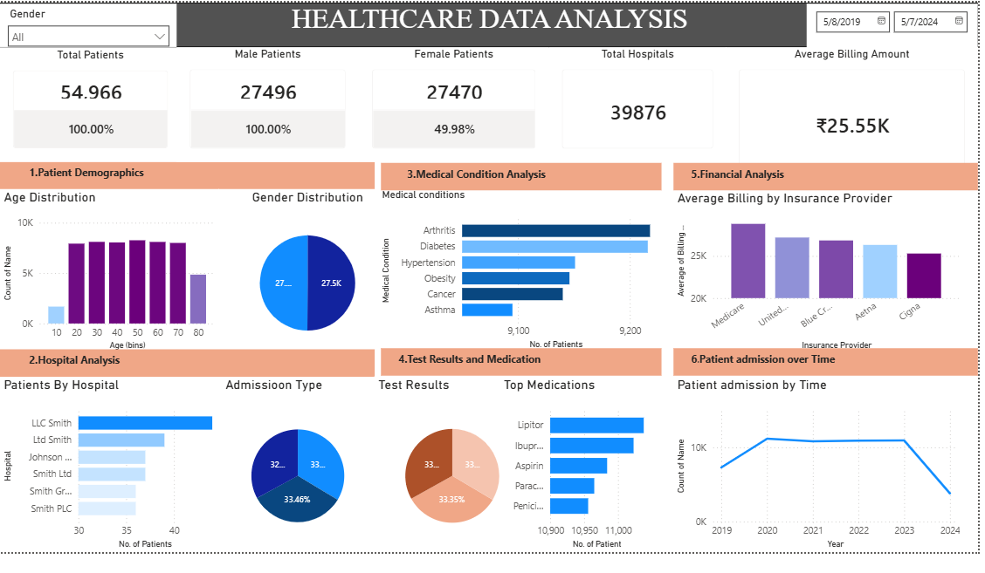.

Medical Conditions
The medical-condition analysis identifies which conditions occur most frequently in the dataset.
Implication: Understanding frequently occurring conditions can help healthcare organizations plan resources such as medical staff, equipment, medicines, and specialized services.
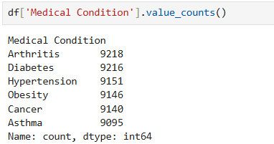

Admission Patterns

The admission analysis compares Emergency, Urgent, and Elective admissions.
Implication: Understanding admission patterns can help hospitals improve staff scheduling, bed allocation, and emergency preparedness.
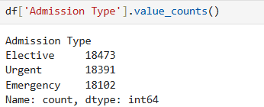

Billing Amount

The billing analysis shows how healthcare costs are distributed across patients.
Implication: Monitoring billing amounts can help healthcare organizations understand cost patterns and improve financial planning.

Test Results
The dataset contains three test-result categories:
- Abnormal
- Inconclusive
- Normal
The relatively balanced class distribution means that class imbalance is not the main reason for the low model performance.
Implication: Additional clinical variables are likely needed to improve prediction.
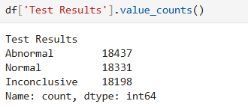

- Predictive Modeling Insights

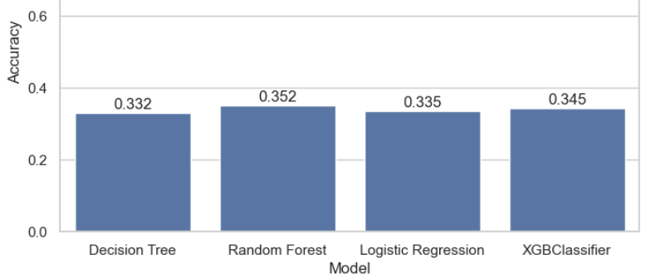

Selected Model: Random Forest
Random Forest was selected because it achieved the highest performance across the tested models.
However, 35.2% accuracy should not be interpreted as a reliable medical prediction system.
Because the target contains three categories, this performance indicates that prediction remains difficult with the currently available variables.
Therefore, the model should not be considered suitable for clinical diagnosis. Instead, it demonstrates the process of applying, comparing, and evaluating machine learning algorithms on healthcare data.

Detailed Model Testing Procedure
The purpose of model testing was to determine how well each trained model could predict Test Results on healthcare records that were not used during training.

Data Splitting Procedure
The cleaned healthcare dataset was divided into:
- 80% training data – used for model training.
- 20% testing data – used only for final evaluation.
random_state=42 was used to make the experiment reproducible. The split was also stratified by Test Results so that the proportions of Abnormal, Normal, and Inconclusive records remained approximately equal in the training and testing sets.
The final test set contained approximately 10,994 records.
The test data was kept separate during training to reduce the risk of data leakage.

Models Tested
Four classification algorithms were evaluated using the same training and testing data:
- Decision Tree
- Random Forest
- Logistic Regression
- XGBoost
Using the same test set for every algorithm made the comparison consistent.

Testing Procedure
For each model, the following procedure was followed:
Step 1: Train the model using only X_train and y_train.
Step 2: Predict Test Results for X_test.
Step 3: Compare predicted results with the actual y_test values.
Step 4: Calculate Accuracy, Precision, Recall, and F1-score.
Step 5: Generate a confusion matrix.
Step 6: Compare misclassification patterns among Abnormal, Inconclusive, and Normal cases.
Step 7: Compare all models and identify the model with the strongest overall performance.
The workflow was:
Training Data → Model Training → Test Data → Prediction → Actual vs Predicted → Metrics → Error Analysis

Testing Metrics
Metric | What Was Checked | Why It Was Used
Accuracy | Overall correct predictions | Measures total predictive performance
Precision | Correctness of predictions for each class | Identifies unreliable positive predictions
Recall | Correctly identified actual cases | Shows whether classes are being missed
F1-Score | Balance of precision and recall | Provides a more complete performance measure
Confusion Matrix | Actual class vs predicted class | Identifies exact types of classification errors
Accuracy was therefore not used alone to select the model.

- Model Comparison
The models produced the following approximate accuracies:
Model | Accuracy | Observation
Decision Tree | 33.2% | Limited predictive performance
Random Forest | 35.2% | Highest accuracy among tested models
Logistic Regression | 33.5% | Predictions strongly concentrated in one class
XGBoost | 34.5% | Close to Random Forest but slightly lower
Random Forest achieved the highest accuracy. However, the difference between Random Forest and XGBoost was small.
Therefore, the result does not indicate that Random Forest solved the prediction problem. It only performed best among the four tested algorithms.

- Specific Error Diagnostics
Model errors were investigated instead of simply reporting the final accuracy.

Class Distribution Diagnostic
The target variable contained:
Test Result | Number of Records
Abnormal | 18,437
Normal | 18,331
Inconclusive | 18,198
These values are very similar. Therefore, severe class imbalance was ruled out as the main explanation for the low accuracy.
This suggests that the problem is more likely related to weak predictive relationships between the available features and Test Results.

Logistic Regression Diagnostic
Logistic Regression achieved approximately 33.55% accuracy, but examining its confusion matrix revealed a serious problem.
Actual Class | Predicted Abnormal | Predicted Inconclusive | Predicted Normal
Abnormal | 3,688 | 0 | 0
Inconclusive | 3,640 | 0 | 0
Normal | 3,666 | 0 | 0
The model predicted nearly every test record as Abnormal.
This means its 33.55% accuracy is misleading when considered alone. It correctly predicted many Abnormal records but failed to distinguish Inconclusive and Normal records.
Diagnostic conclusion: Logistic Regression did not learn useful boundaries between the three Test Result categories.

Random Forest Diagnostic
Random Forest achieved approximately 35.2% accuracy, the highest among the tested models.
For approximately 10,994 test records:
Correct predictions ≈ 3,870
Incorrect predictions ≈ 7,124
Therefore, approximately 64.8% of test records were still classified incorrectly.
This shows that Random Forest is the strongest model in the experiment, but its predictions are not sufficiently reliable for clinical use.

Algorithm Complexity Diagnostic
Decision Tree achieved approximately 33.2%, XGBoost approximately 34.5%, and Random Forest approximately 35.2%.
The relatively small difference between simple and advanced algorithms is important.
If model complexity were the main problem, a stronger improvement would be expected when moving from Logistic Regression or Decision Tree to ensemble algorithms such as Random Forest and XGBoost.
Since this did not occur, the experiment indicates that feature quality and feature relevance are more important limitations than algorithm complexity.

Feature Diagnostic
The current dataset contains variables such as Age, Gender, Medical Condition, Admission Type, Billing Amount, Insurance Provider, Medication, and other administrative/demographic information.
However, Test Results may depend more directly on clinical measurements such as:
- Laboratory values
- Blood pressure
- Heart rate
- BMI
- Symptoms
- Disease severity
- Previous diagnoses
- Medical history
The absence of these variables is a likely limitation of the prediction task.

- Improvement Roadmap
Instead of only suggesting general improvements, the following staged roadmap defines what should be changed, how it should be tested, and how success should be measured.

Phase | Specific Action | Testing Method | Expected Evidence of Improvement
1. Data Audit | Recheck missing values, duplicates, data types and invalid values | Run automated validation checks | Cleaner and consistent dataset
2. Feature Improvement | Add lab results, vital signs, BMI, symptoms and medical history | Compare models before and after adding features | Increase in F1-score/accuracy
3. Feature Engineering | Create age groups, length of stay and relevant derived variables | Train models with and without engineered features | Determine whether new features improve prediction
4. Cross-Validation | Apply stratified 5-fold cross-validation | Compare mean and variation of validation scores | More reliable estimate than one train-test split
5. Hyperparameter Tuning | Tune Random Forest and XGBoost parameters | GridSearchCV/RandomizedSearchCV | Improved validation metrics
6. Error Re-analysis | Generate new confusion matrices | Compare class-level errors before and after improvements | Fewer systematic misclassifications
7. Final Evaluation | Evaluate the improved model on untouched test data | Accuracy, precision, recall and F1-score | Evidence of generalization
8. Reporting | Present final results through dashboard and report | Compare baseline and improved model | Clear communication of measurable improvement

- Focused Recommendations
Based specifically on the results of this project, the following recommendations are prioritized.

Priority 1 – Improve Predictive Features
This should be the first priority because all four models produced similarly low accuracy. Future datasets should include laboratory values, vital signs, BMI, symptoms, disease severity, and medical history.
Reason: Changing algorithms alone produced only small improvements.

Priority 2 – Use Stronger Validation
Use Stratified 5-Fold Cross-Validation instead of depending only on a single 80/20 split.
Reason: Cross-validation will show whether the approximately 35.2% Random Forest result is stable across different subsets of the dataset.

Priority 3 – Perform Hyperparameter Tuning
After improving the features, tune Random Forest parameters such as:
- n_estimators
- max_depth
- min_samples_split
- min_samples_leaf
- max_features
Reason: Tuning should be performed after improving feature quality rather than treating model complexity as the main solution.

Priority 4 – Repeat Error Analysis
After every major improvement, generate a new confusion matrix and compare:
- Abnormal → Inconclusive errors
- Abnormal → Normal errors
- Inconclusive → Abnormal errors
- Inconclusive → Normal errors
- Normal → Abnormal errors
- Normal → Inconclusive errors
Reason: An improved model should reduce specific classification errors, not merely increase overall accuracy.

Priority 5 – Separate Analytical and Clinical Use
The current Random Forest model should remain an analytical demonstration and should not be used for diagnosis or treatment decisions.
The dashboard and descriptive analysis can still be useful for understanding patient demographics, admission patterns, medical conditions, and billing trends.

- Expected Improvement Cycle
The proposed improvement process can be summarized as:
Current Model (35.2%)
↓
Diagnose Errors
↓
Improve Data Quality
↓
Add Relevant Clinical Features
↓
Feature Engineering
↓
5-Fold Cross-Validation
↓
Hyperparameter Tuning
↓
Recalculate Metrics
↓
Compare Confusion Matrices
↓
Accept Improvement Only if Test Performance Improves
This creates a measurable improvement cycle rather than simply trying additional algorithms.

- Conclusion
Week 5 converted the results of the Healthcare Data Analysis project into evidence-based findings and recommendations. A structured testing procedure was used to compare Decision Tree, Random Forest, Logistic Regression, and XGBoost on unseen test records using accuracy, precision, recall, F1-score, and confusion matrices.
Random Forest achieved the highest accuracy of approximately 35.2%, but detailed error analysis showed that approximately 64.8% of test predictions were still incorrect. Logistic Regression provided an important example of why accuracy alone is insufficient, as its predictions were strongly concentrated in the Abnormal class. The balanced distribution of Abnormal, Normal, and Inconclusive records also indicated that severe class imbalance was not the main reason for weak performance.
The diagnostic analysis suggests that the major limitation is the predictive information available in the dataset rather than simply the choice of algorithm. Therefore, the improvement roadmap prioritizes richer clinical features, feature engineering, stratified cross-validation, hyperparameter tuning, and repeated error analysis.
Overall, Week 5 demonstrates that a successful predictive analytics project requires more than selecting the model with the highest accuracy. It requires systematic testing, diagnosis of specific errors, measurable improvements, and careful interpretation of model limitations.

